Miji Concert no. 9: Voice and Electricity

Audrey Chen & Phil Minton duo
Li Jianhong & Mars Impro Committee
Pm 8:30, June 21st 2012; 2Kolegas (www.2kolegas.com); rmb 60

(Other cities: June 15th at 696Live, Shanghai, with Yan Jun + Free Music Collective of Shanghai; June 17th at Yidutang, Shenzhen, with Jun-Y Ciao; June 23rd at Banpo Art Zone (Zhangguanlidai Festival), Xi’an, with Yan Jun)

Origin:
Quote from press kit: “The duo of Audrey Chen and Phil Minton began several years ago in 2006 and has been steadily developing since that time into a truly unique ensemble.
With primary focus on the interplay between the uttered sounds of the mouth and vocal chords, Minton and Chen plumb the depths of their most inherent and bodily instruments; their voices. Their improvisations are fearless, fragile, hungry, passionate, riotous, ululating and animalistic yet are, in all respects, human. They are, in collaboration, expressing, pronouncing and articulating (in their fashion) the many nuanced shades of their individual conditions.”
But these are not new names for us. As Audrey is good friend of many Chinese impro musicians. She has toured in China twice. Attended 2pi festival and Waterland Kwanyin. Her voice could be as sharp as from electronic device. Her cello playing is unique and warm. She is definitely a new star in the international improvised music scene.
Phil Minton is, no doubt, one of the masters in our time. He is a magician of lips and throat. As a traveling musician without luggage he devoted his body to the stage for decades. How many musicians got influence from him by his countless performance, discs and workshops?
Btw, he will hold a workshop for the Mars Impro Committee before the concert. So we will see a small festival of voice!

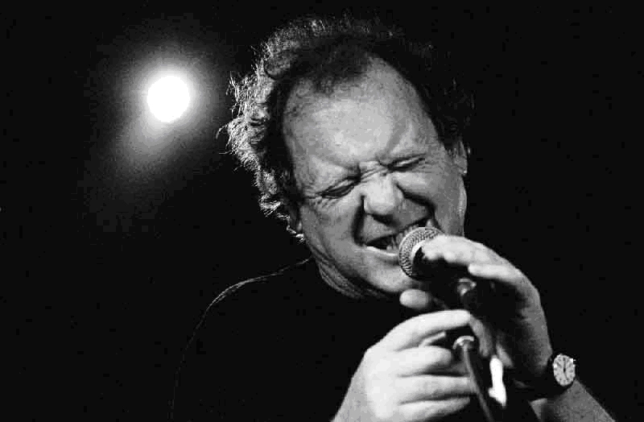
PHIL MINTON, born in Torquay, UK in 1940. Both his parents were singers. He learnt trumpet from age 15 and played and sang with local jazz groups, moving to London in 63 to play with Mike Westbrook. From the mid 60's he worked in dance bands in the UK, Canary Islands and Sweden. Rejoining Westbrook in 72 he was a regular member of his Brass Band until 84, playing trumpet and singing extensively in Europe, USA and beyond.

Through the last 30 years he's worked mainly as an improvising singer and sung with most of the worlds leading improvising musicians as well as been a guest singer for many composers music. He collaborated with pianist Veryan Weston on compositions such as "Songs from a Prison Diary" and is currently a member of improvising groups TooT, No Walls, 5 Men Singing, fORC, Adorno, Speeq and Axon. He also has a quartet with Veryan, John Butcher, and Roger Turner, and plays duos with these three musicians. New working duos are with singers and musicians, Isabelle Duthoit, Maggie Nicols, Audrey Chen, Terry Day, Hugh Metcalfe, Daunik Lazro and Sophie Agnel. He was a Nesta awardee in 2005 and in the last 15 years has traveled to many countries with his "Feral Choir" - a workshop and concert for all people who want to sing.

www.philminton.co.uk

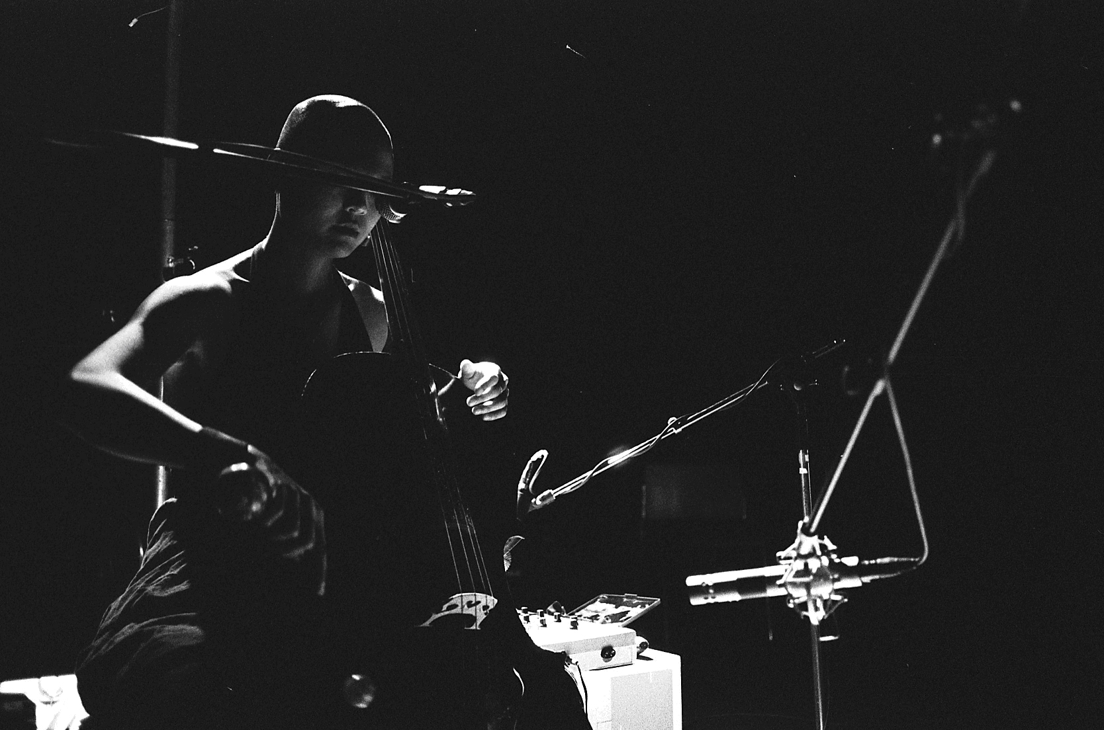

AUDREY CHEN is a Chinese-American musician who was born into a family of material scientists, doctors and engineers, outside of Chicago in 1976. Parting ways with the family convention, she turned to the cello at age 8 and voice at 11. After years of classical and conservatory training in both instruments, with a resulting specialization in early and new music, she parted ways again in 2003 to begin new negotiations with sound in order to discover a more individually honest aesthetic.

Now, using the cello, voice and analog electronics, Chen’s work delves deeply into her own version of narrative and non-linear storytelling. A large component of her music is improvised and her approach to this is extremely personal and visceral. Her playing explores the combination and layering of a homemade analog synthesizer, preparations and traditional and extended techniques in both the voice and cello. She works to join these elements into a singular ecstatic personal language.

Chen has performed in Europe, Russia, Australia, New Zealand, China, Japan, Taiwan, Brazil, Canada and the USA. She has recently relocated to Berlin, Germany from Baltimore, MD USA and continues to maintain an active international touring schedule.

This year, 2012, she will be touring solo and with her two current duo projects with Phil Minton and KAMAMA, with drummer, Luca Marini. Two album releases include a trio with Nate Wooley and C. Spencer Yeh on Monotype (Warsaw), and a duo record with Phil Minton on Subrosa (Brussels). New upcoming projects include work with violinist, Jon Rose, guitarist and composer, Jean-Yves Evrard, the German artist, John Bock and with the widely acclaimed Kronos Quartet.

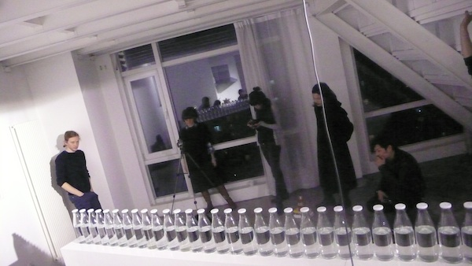

Li Jianhong
Li Jianhong is one of the most active Chinese noise / Improvisation artists in Mainland China of present days. His involvement in China’s experimental culture started since the late 1990s, being the founder of several groups such as the Second Skin, D!O!D!O!D! and members of groups such as Pisces Iscariots and VagusNerve.
As the manager of the independent label 2pi Records and the founder of the art group Tome Club, Li Jianhong curated a noise / sound art / Avant-garde music festival “2pi Festival” since 2003 and held it annually in Hangzhou until 2007. As the most important Avant-garde music festival in China, 2pi Festival invited not only the most active avant-garde musicians in China, but also experimental artists from abroad, which contributed a lot to the growth of China’s new music scene. Meanwhile, Li Jianhong created an organizing form of noise music, named it “Home Violence” and held series performances to push the noise / experimental scene into households. In 2011, he together with VAVABOND established a new label C.F.I. (China Free Improvisation) to promote the development of China’s free improvisational music.
http://www.china-free-improv.com/?p=676

Mars Impro Committee
an improvised music group that always changes its line-up with specific workshops and rules. Most members are young musicians from Beijing. But it also includs musicians from other cities in China, other countries, and the older generation. So far Impro Committee has avatars including Winter Impro Committee, Ad Hoc Impro Committee, Friends Impro Committee and Mars Impro Committee.
Yan Jun (sunflower seeds, electronics), Li Zenghui (voice, saxophone), Yan Yulong (violin), Shou Wang (guitar, electronics), Shi Yang (laptop, objects), VAVABOND (laptop), Jun-Y Ciao (saxophone, clarinet)

Presented by Sub Jam
www.subjam.org

supported by British Council (as part of UK NOW)
http://www.britishcouncil.org.cn

